Pictures are in the “MEET THE STAFF” folder, labeled as \***NAME* CIRCLE**

| **Name** | **Position** | **Bio** |
| --- | --- | --- |
| Olga M. Correa  ocorrea@umass.edu | Director and Course Instructor | Olga is the interim Director and Course Instructor for Student Bridges Agency. She earned a Bachelor of Arts in Sociology from William Paterson University and a Master’s degree in Higher Education Administration from UMass’ College of Education. As a current 4th year Educational Leadership and Policy Phd student at UMass, her research explores racial inequities among Black and Latino youth in K-12 suburban schools. Olga is a first-generation college student and experienced many hardships navigating the terrain of higher education. She is committed to working alongside K-12, undergraduate , and graduate students to address issues of access and equity in education. |
| Donald Fonseca  sbgpc-sa@umass.edu | Graduate Program Coordinator | Donald is the Graduate Program Coordinator (GPC) for the Student Bridges Agency. He earned his BA in Geography Education in Jamaica. Donald also obtained a Bsc from Boston University in Urban Affairs/City Planning, and an MA from Brandeis in Sustainable International Development. He is currently pursuing a PhD in Environmental Conservation at the University of Massachusetts Amherst. Donals has over 20 years of experience in teaching and community development, and is dedicated to helping others achieve their goals. |
| Becca Louisthelmy  sbupc1-sa@umass.edu | Undergraduate Program Coordinators | Becca is the Undergraduate Program Coordinator for Student Bridges Agency. She is currently a senior studying biomedical engineering. She plans to pursue her PhD in biomedical engineering upon completion of her bachelor's degree. Becca also serves as the President of the Black Student Union and the Cultural Council and is a research assistant for the Cornelison Group on campus. Becca is a first-generation, Haitian-American student who is extremely passionate about social justice and increasing access in higher education, specifically STEM related studies for black and brown women. |
| Yekalo Tesfazion  sbupc2-sa@umass.edu | Undergraduate Logistics Coordinator | Yekalo is a senior majoring in Public Health and is originally from Boston, MA. He serves as the Undergraduate Logistics Coordinator for Student Bridges. Yekalo was first introduced to SB through his sister who encouraged him to visit the office and attend SB Night during her senior year. This helped him get more involved by taking SRVCLRNG 293, allowing him to get a better sense of the agency’s principles and focus. Coming from an immigrant household, Yekalo is aware of the many challenges that arise from the college application process and navigating the different spaces within these institutions. Yekaolo’s goal with Student Bridges is to improve access and success for underrepresented students on the university campus and neighboring communities by collaborating with campus partners and offering resources for college awareness, preparation, and success. |
| Brianna Bolivar  sbpr-sa@umass.edu | Public Relations Coordinator | Brianna is a senior majoring in Public Health, is on the pre-health track, and would love to pursue a career as a Physician Assistant. She serves as the Public Relations coordinator for SB. As the daughter of Haitian immigrant parents, Brianna is passionate about the power of knowledge and access to education and is well aware of the barriers put in place for those belonging to underrepresented and marginalized groups. She is aware of the difficulties posed by unfamiliarity with navigating the college application process for both students and parents and aims to be a support for students. Brianna is a strong believer in equipping individuals with the necessary and specific tools to achieve greatness. Her hope is to pass down the insight that has furthered her success and mentor students to attain their fullest potential and purpose. |
| Carl Marcelin  sbsitecoord2-sa@umass.edu | Springfield Community Site Coordinator | Carl is a senior majoring in Kinesiology and is also pursuing a certificate in Medical Humanities. He serves as the Springfield Site Coordinator for Student Bridges. Carl began his journey with SB when he took our service-learning course as a second- semester freshman. As a first-generation college student and a Haitian immigrant, Carl is well aware of the trials and tribulations that surround the college application process and the burden of living up to familial expectations. Motivated by those who helped him become the person he is today, his goal with Student Bridges is to serve the community as a leader who supports and encourages students like himself to become the leaders of tomorrow. |
| Mahoro Shimiro  [sbsitecoord1-sa@umass.edu](mailto:sbsitecoord1-sa@umass.edu)  (recently added, picture is in the folder) | Holyoke Community Site Coordinator | Mahoro is a senior majoring in Sustainability and Community Development. She serves as the Holyoke Site Coordinator and has been in this role since 2020. Mahoro has worked with Upward Bound as a Tutor/Mentor and is aware of the challenges that the college application process presents. She puts forward her knowledge and engagement skills during workshops with local high schools throughout the academic year. |
| Haniyah Broadway  sbenrichment-sa@umass.edu | Retention Enrichment Coordinator | Haniyah is a freshman majoring in Social Thought and Political Economy on the pre-physician assistant track and serves as the Retention Enrichment Coordinator at Student Bridges. Haniyah started playing hockey with S.C.O.R.E Boston and then became a teen coach where she learned her passion for helping her community where hockey was not a very accessible sport to her community compared to more affluent ones. At UMass, she found Student Bridges and knew it was going to be a great fit for her to be able to help other underrepresented and first generation students. |
| Celi Arias  sbpolicy-sa@umass.edu | Policy Advocacy Coordinator | Celineydi Arias, who goes by Celi, serves as Policy Advocacy Coordinator for Student Bridges Agency. Celi is a freshman and public health major. She was born and raised in Boston. As a first generation college student, she understands how difficult the college application process can be and how important it is to get an education. Celi is passionate about helping other students like herself, get access to resources and the support they need to succeed. |
| Alexis Bester  (no email, graduated in the Fall but should still be listed) | Office Manager | Alexis is a senior majoring in Public Health on the PA track. She serves as the Office Manager for Student Bridges and wanted to get involved with Student Bridges after her connections with the Upward Bound Program in high school and here at UMass. Alexis is a first-generation college student and is excited about giving minority students guidance and access to higher educational opportunities the same way she was. With this position, she hopes to create a welcoming environment, to learn more about SB and work closely with the entire staff to fulfill the agency’s mission. |
| Tina Noël  sblogistics-sa@umass.edu | Office Manager | Tina is a senior in the college of Natural Sciences majoring in Biology on a pre-med track. She serves as the office manager for SB and as the president of the NAACP Chapter at UMass. As a Haitian immigrant, she understands the struggles of coming from a low-income family and navigating school as a first-generation student. To give back to her community, she volunteers for the Center of Americans teaching immigrants ESOL and aiding them with their citizenship applications. She plans to provide as much support as she can to minority students through SB. She hopes to open her own dermatology clinic one day to serve underprivileged communities in Boston. |
| Yoen Pedraza  sbmentorship-sa@umass.edu | Retention Mentorship Coordinator | Yoen is a junior majoring in Psychology who is considering double majoring in Biology or minoring in Biology. Yoen is from Fitchburg, MA and attended Fitchburg University for two years and this is his first semester at UMass. He was introduced to Student Bridges through a high school friend, and former SB employee, who believed he could greatly benefit from the program. Yoen is a first generation college student and comes from an immigrant household - he set out to serve as the Retention Mentorship Coordinator to help do his part to bridge the gap of higher education and first generation college students as he has often endured the struggles of applying to college himself. Yoen is also a member of the UMass Boxing team and serves as the manager of their social media page. He is committed to working with people to help them minimize the obstacles that stand in the way of many people in regards to college access as well as help inspire others to always dream bigger. |
| Vanessa Antenor  sbcocaevents-sa@umass.edu | Community Outreach and College Access Events & Tours Coordinator | Vanessa is a sophomore majoring in Biochemistry. She is also involved in SoCA and HASA executive boards. She serves as the COCA Events and Tours Coordinator for SB. She wanted to get involved in SB after seeing what their mission was and wanted to be a part of this association. Coming to the United States as a teenager from Haiti made her understand that this country does not really offer a lot to teens unless you find access to resources that will help you be successful. Therefore, with this position, she is hoping to help as many students as possible find the resources needed to reach their goals. |
| Bryanna Mejia  sbaccountant-sa@umass.edu | Financial Coordinator | Bryanna is a junior majoring in Kinesiology. She serves as the financial coordinator at Student Bridges. With having Honduran immigrant parents, Bryanna wanted to get involved with SB in order to help those who are also first generation college students. She understands the pressure a first-gen student may have to be successful and graduate from college; little do they know this agency can assist them to that path to success! |
| Michelle Gitau  sbcocatours-sa@umass.edu | Community Outreach and College Access Events & Tours Coordinator | Michelle is a senior majoring in Psychology with a Neuroscience concentration on the pre-med track. She is also pursuing a Spanish and Health certificate. She is serving as COCA Events and Tours Coordinator for SB and wanted to get involved in SB after discussing all its opportunities with SB alumni. Michelle is Kenyan-American first-generation college student who is heavily involved on campus in different cultural, academic and religious organizations serving on the executive board of 6 different organizations. With this position she hopes to share resources to better aid the success of minority students and help them feel heard and accepted on campus. She also aspires to advertise different ways to get involved on campus to foster a sense of community among underrepresented minority students at UMass. |
| Nahom Daniel  sbrecruitment-sa@umass.edu | Recruitment Coordinator | Nahom is a senior majoring in Public Health with a focus in Health Administration and Public Policy. Originally from Malden, MA, Nahom has grown up around many different cultures and traditions. Serving as our Recruitment Coordinator, Nahom is very involved in our communities and engaging participation for Student Bridges. Being introduced to SB through his fellow peer Yekalo, Nahom has found Student Bridges to be a safe haven for him on campus. He considers it a place where he can go and freely be himself, engage in conversation, and focus on his studies. As a first generation college student that comes from an immigrant household, Nahom is aware of the many challenges that arise from the college application process and aspires to help students navigate the different spaces within these institutions. |

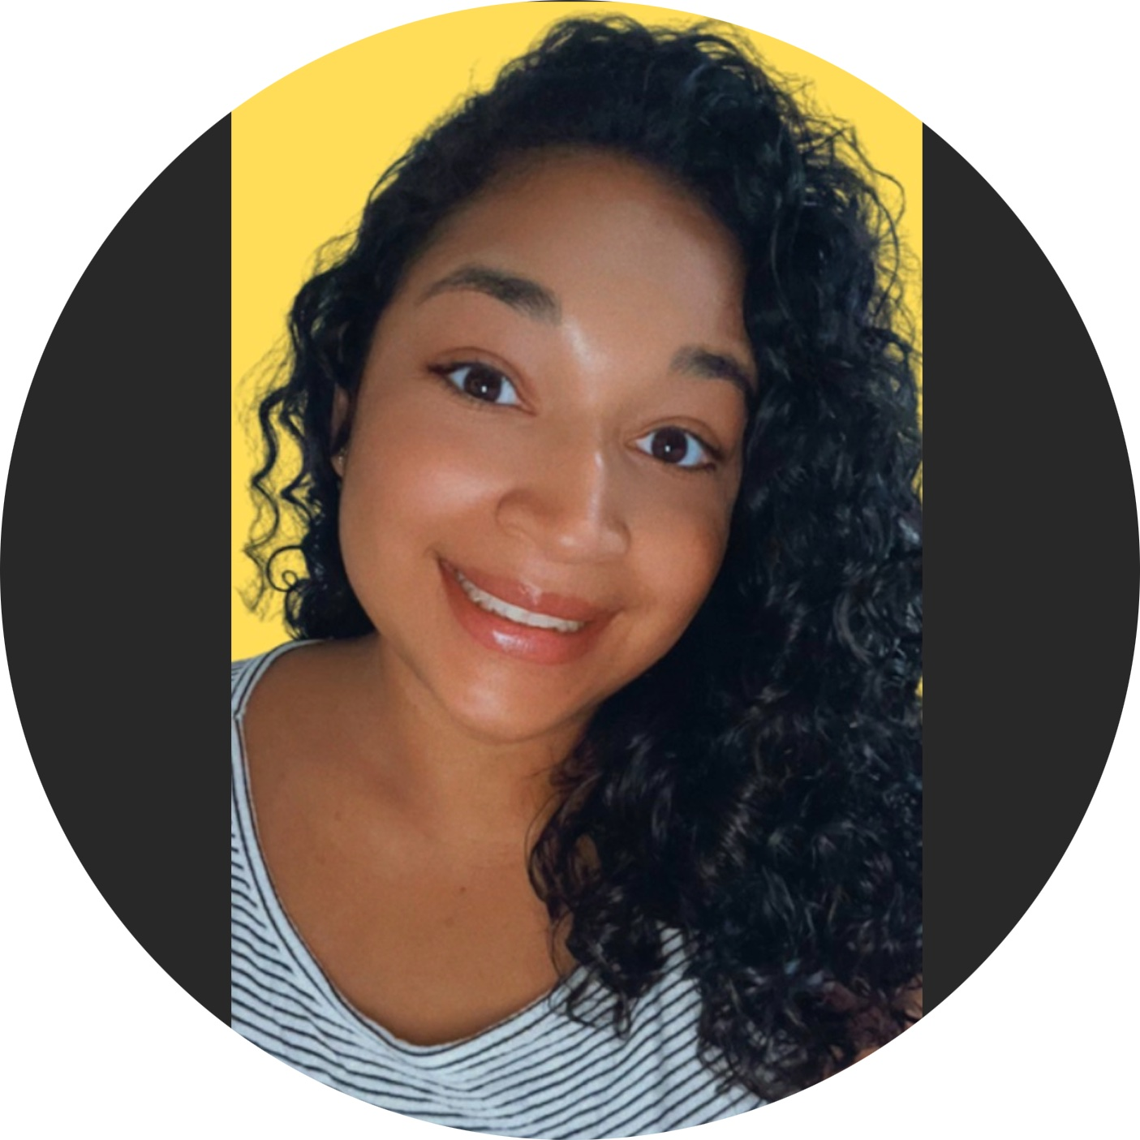 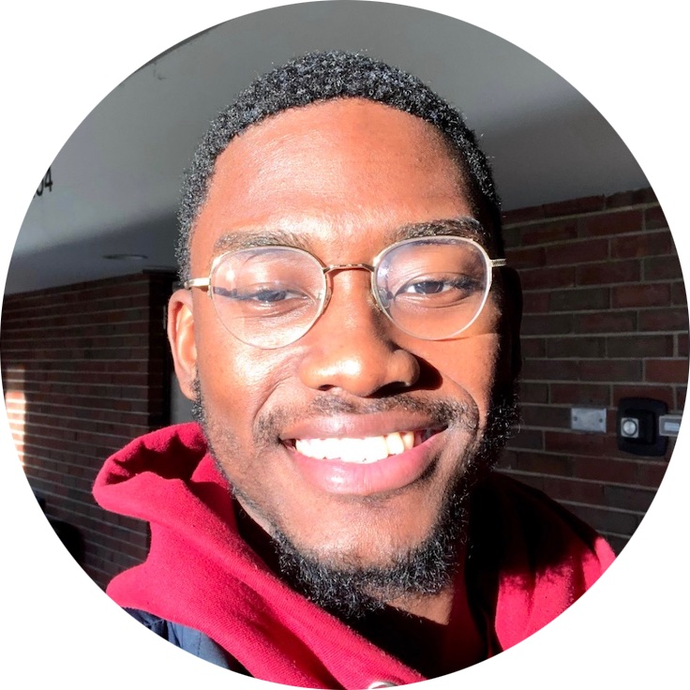- Carl

-Olga

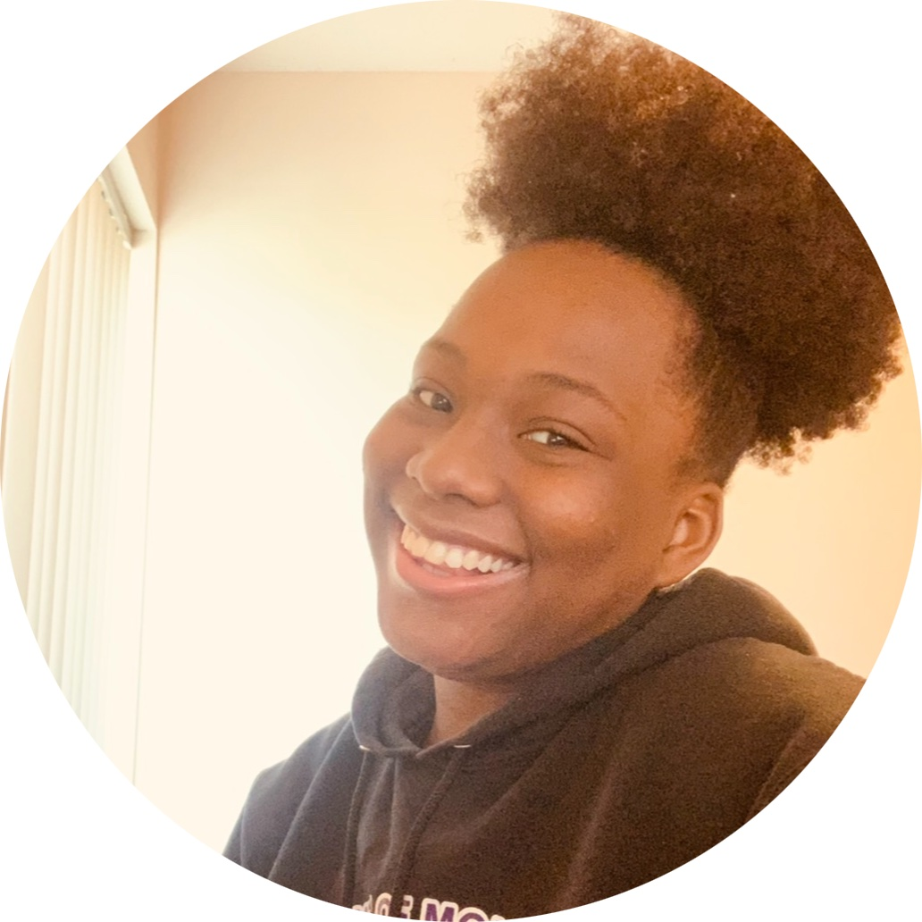 Becca 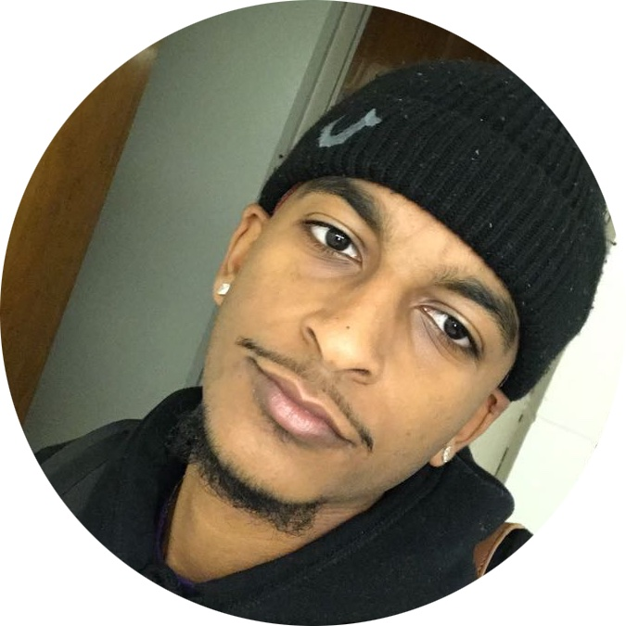yekalo

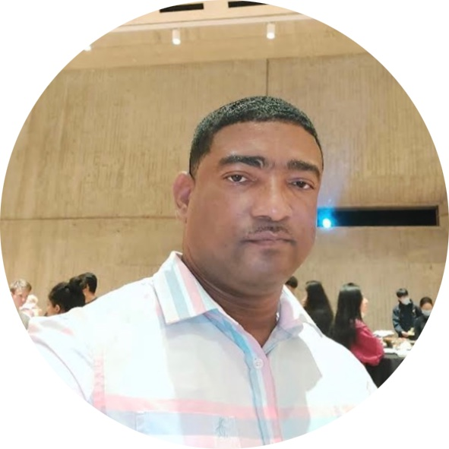 Donald 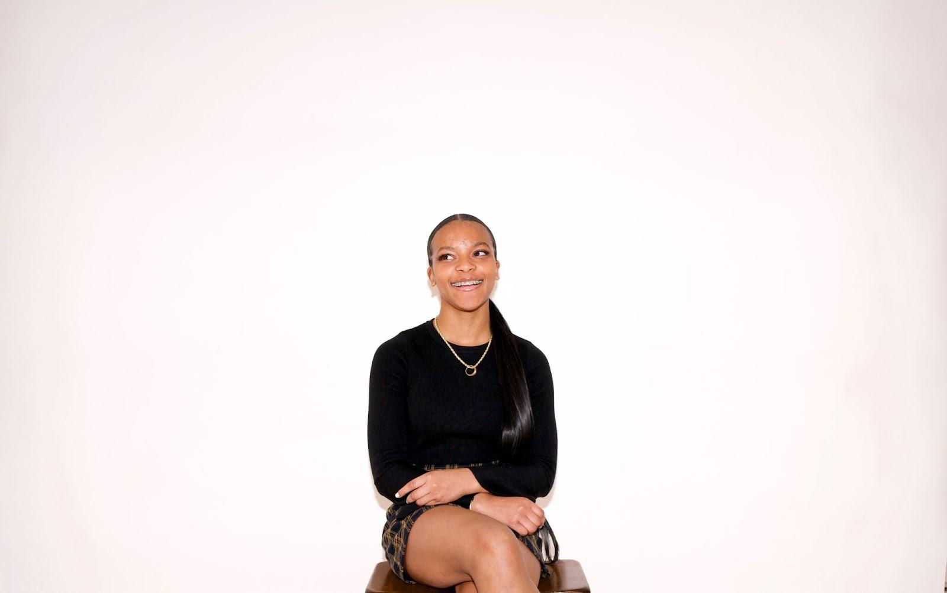 Haniya

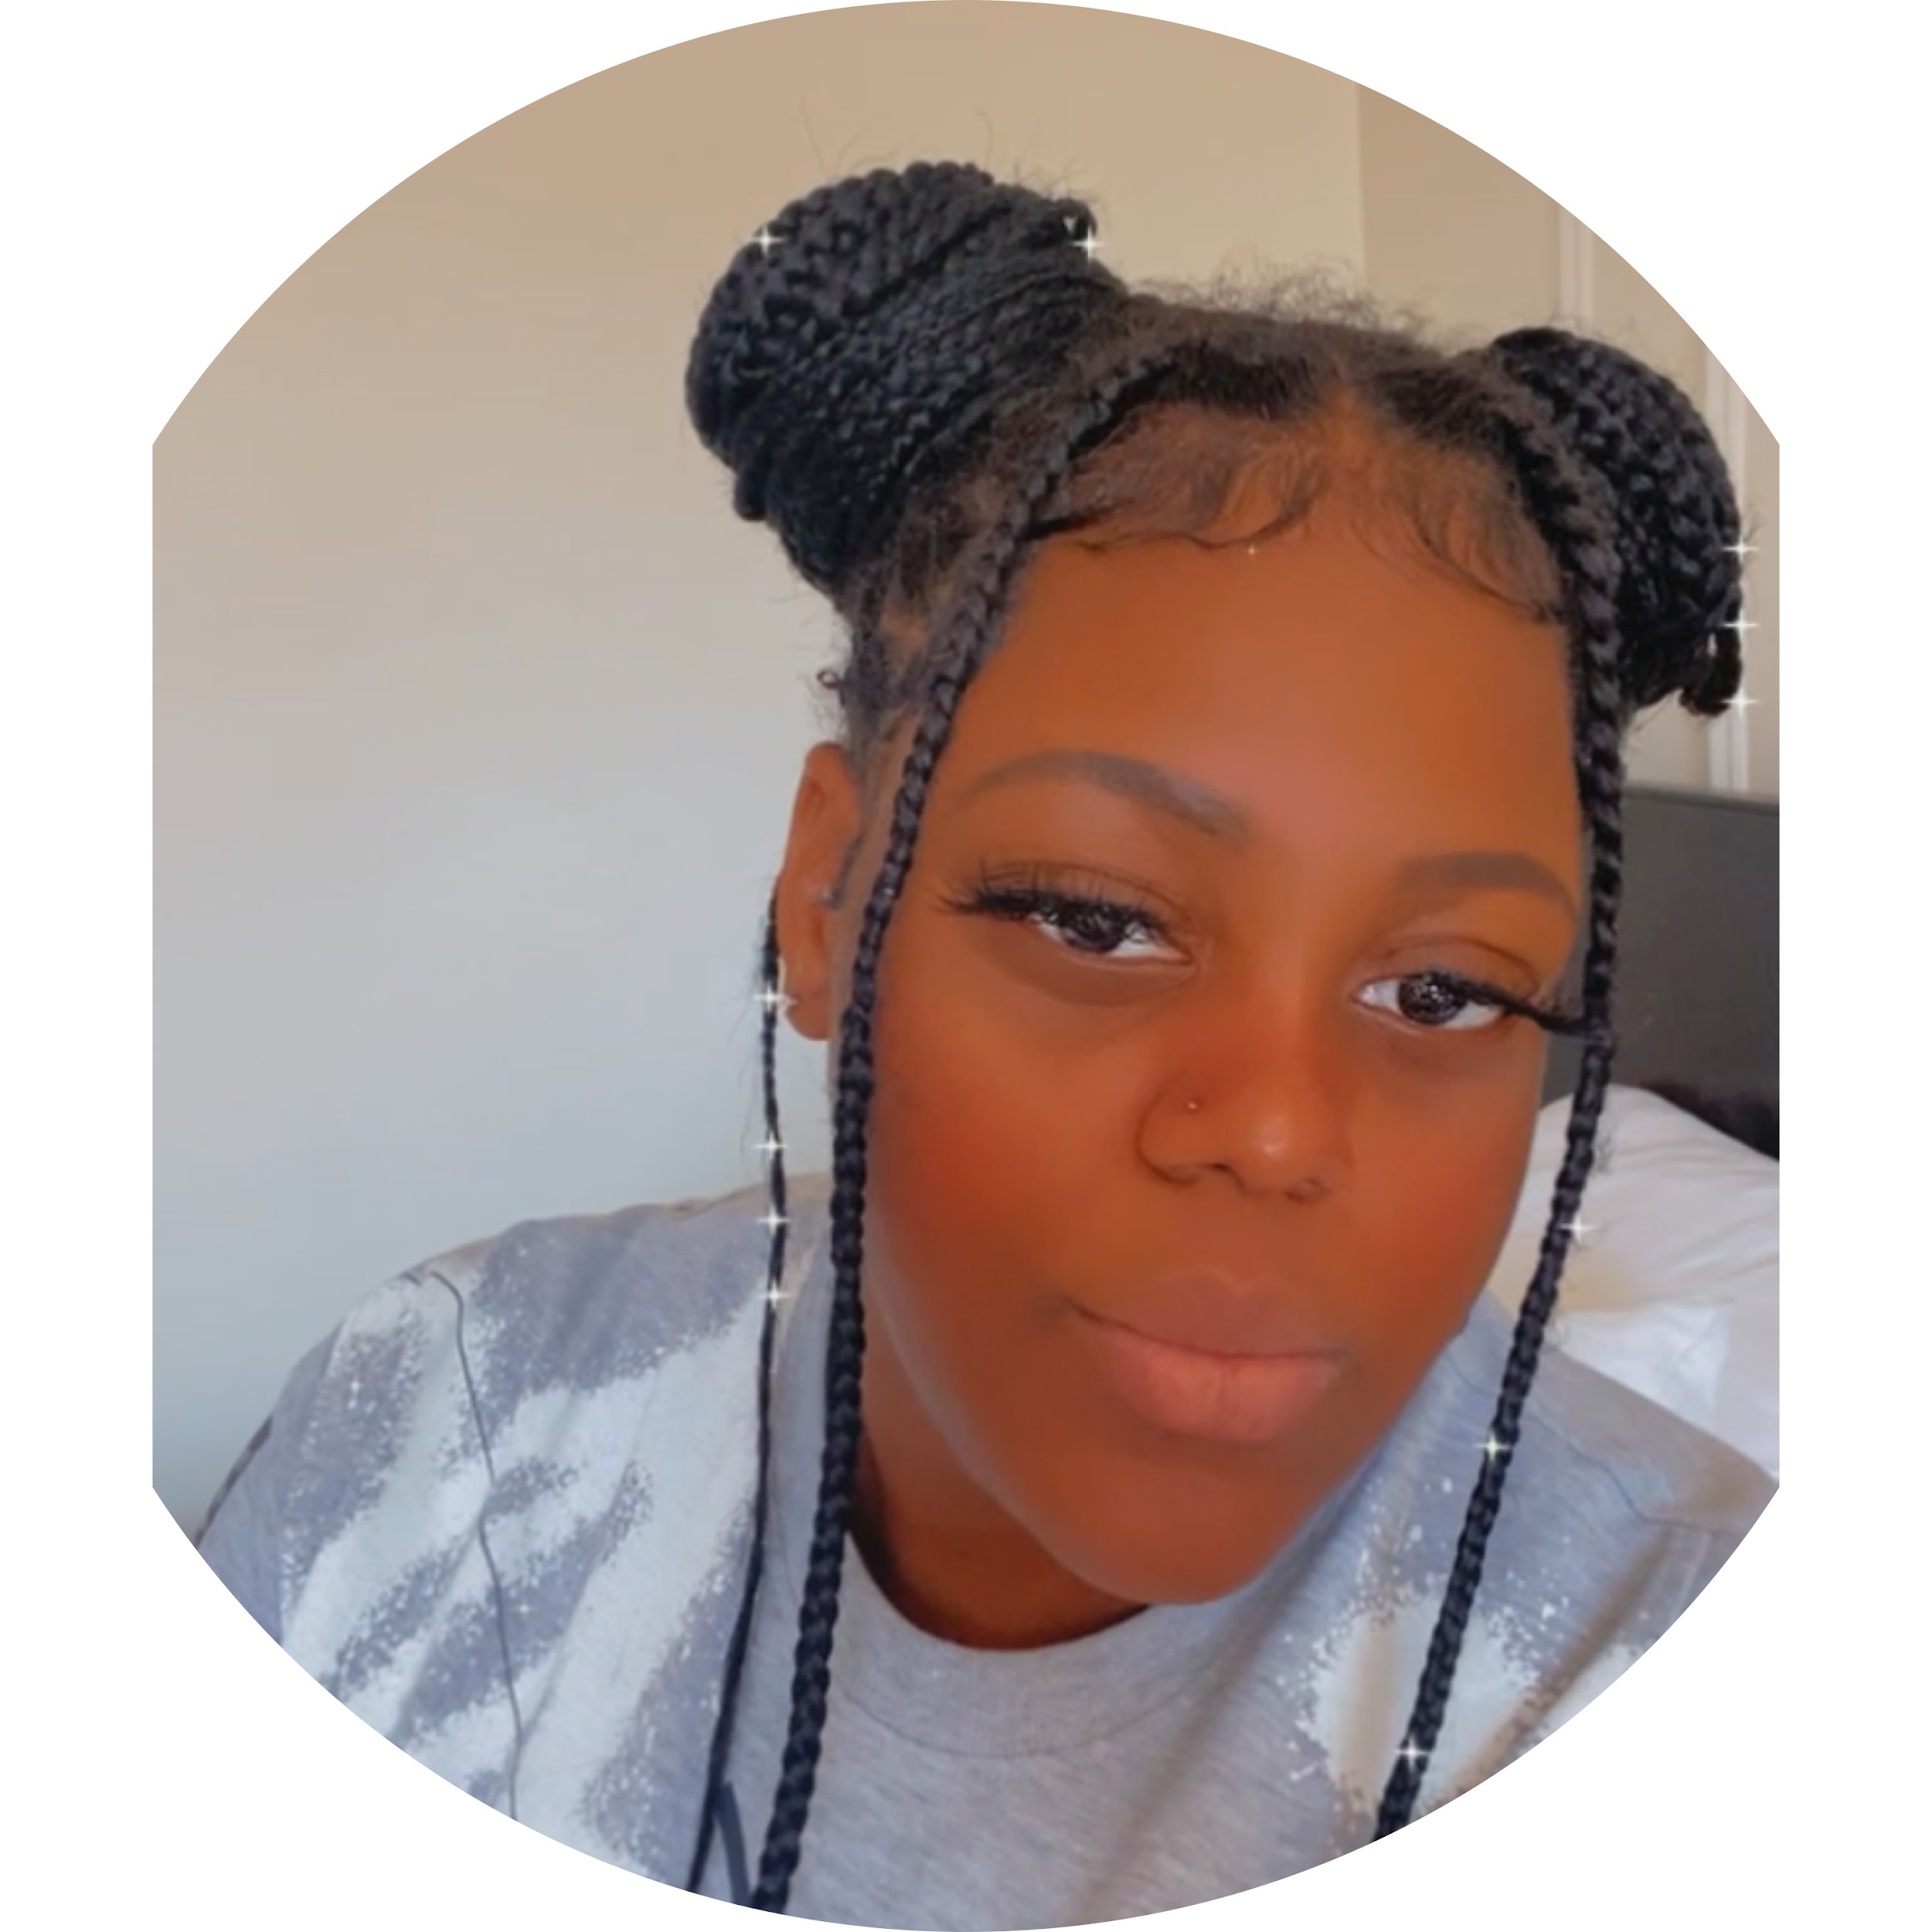 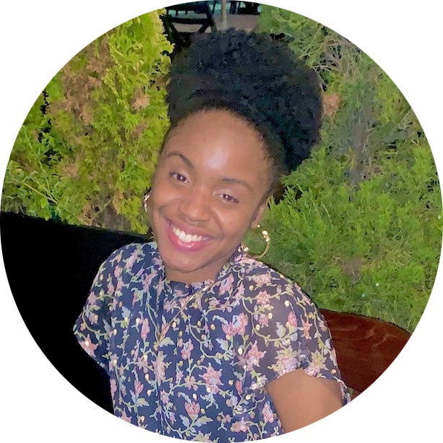Brianna

Vanessa

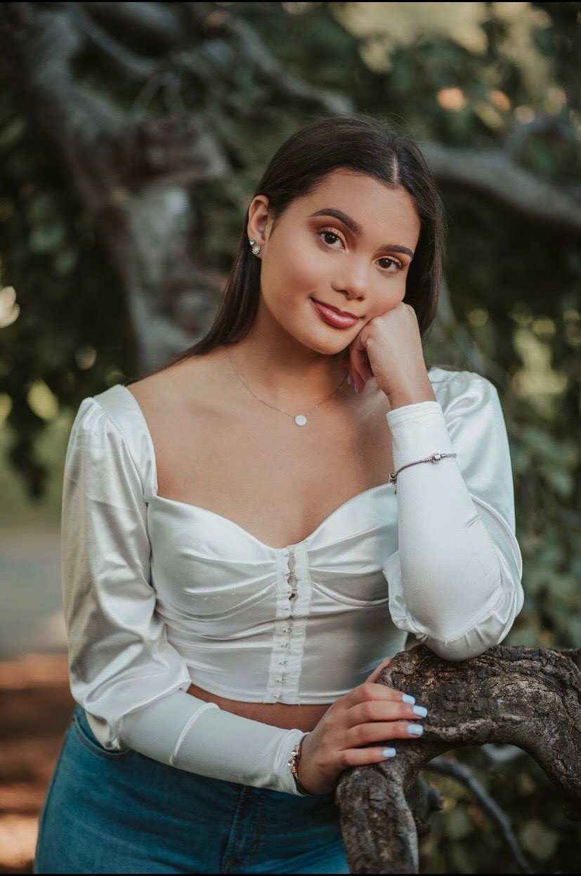 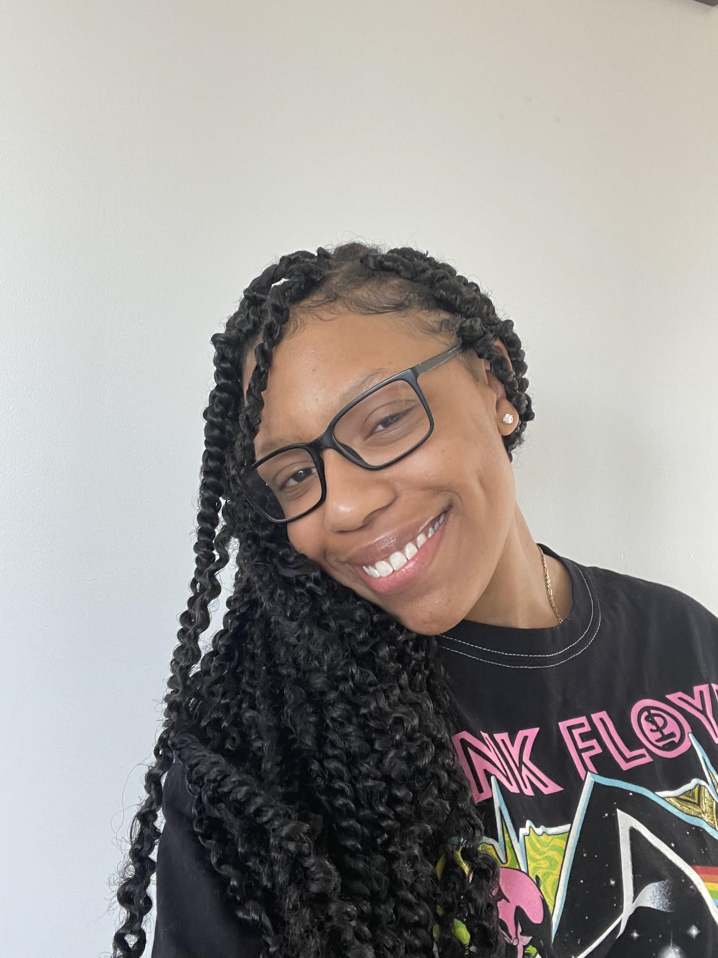 Alexis

Celi

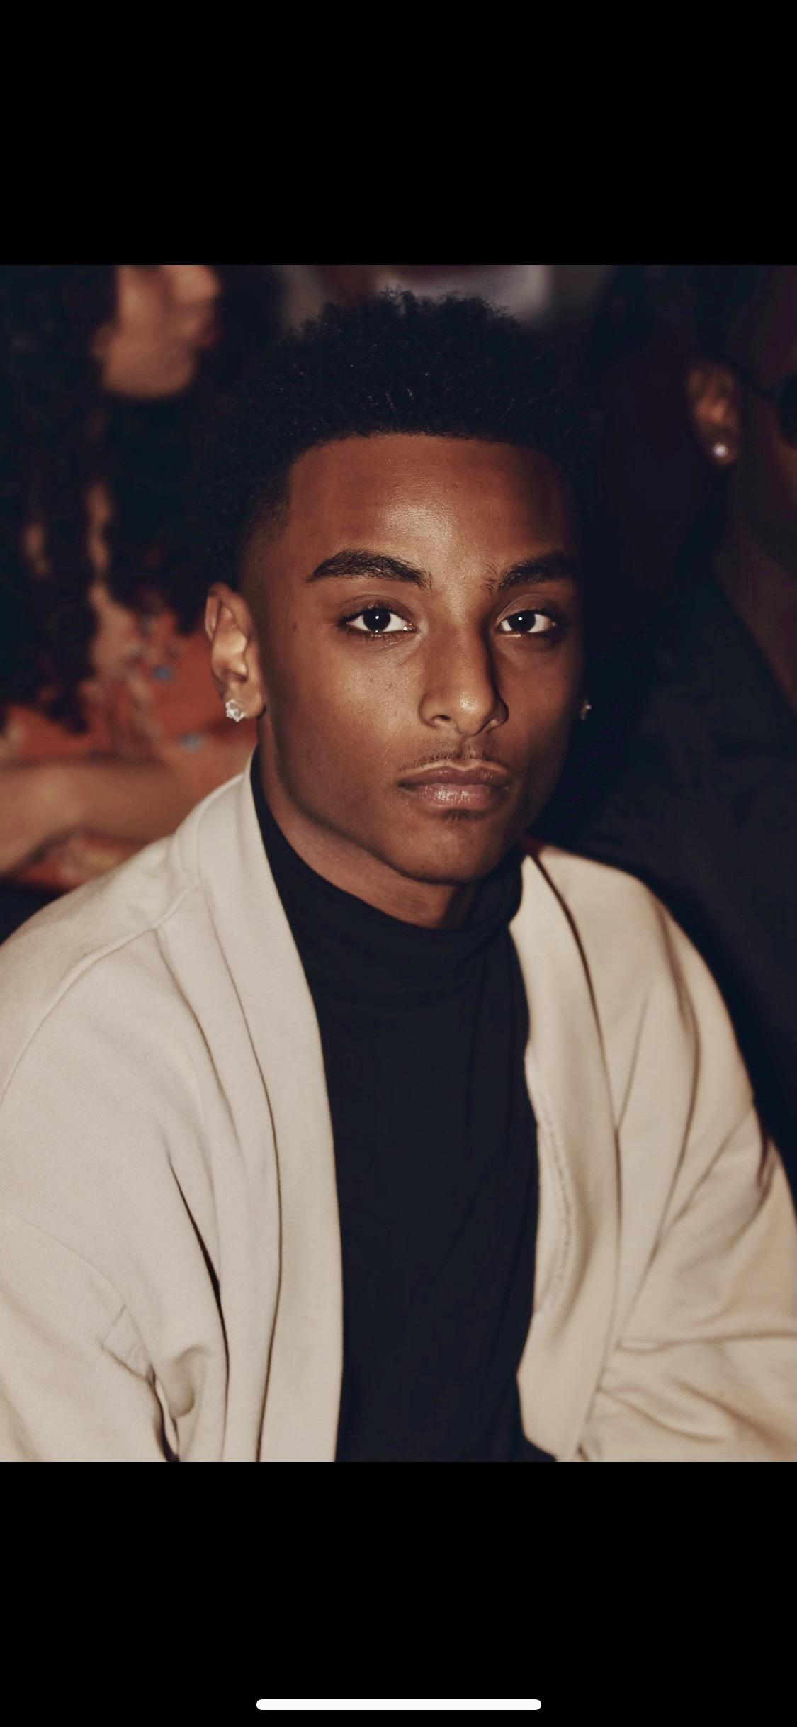 Nahom 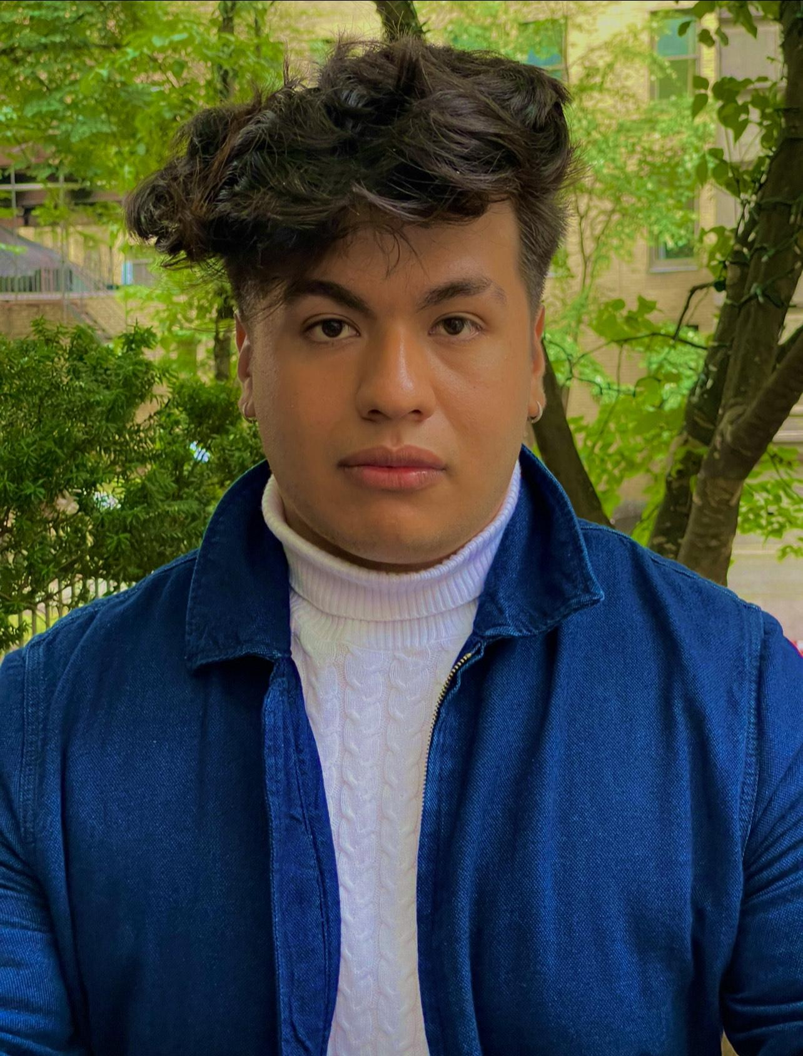 Yoen

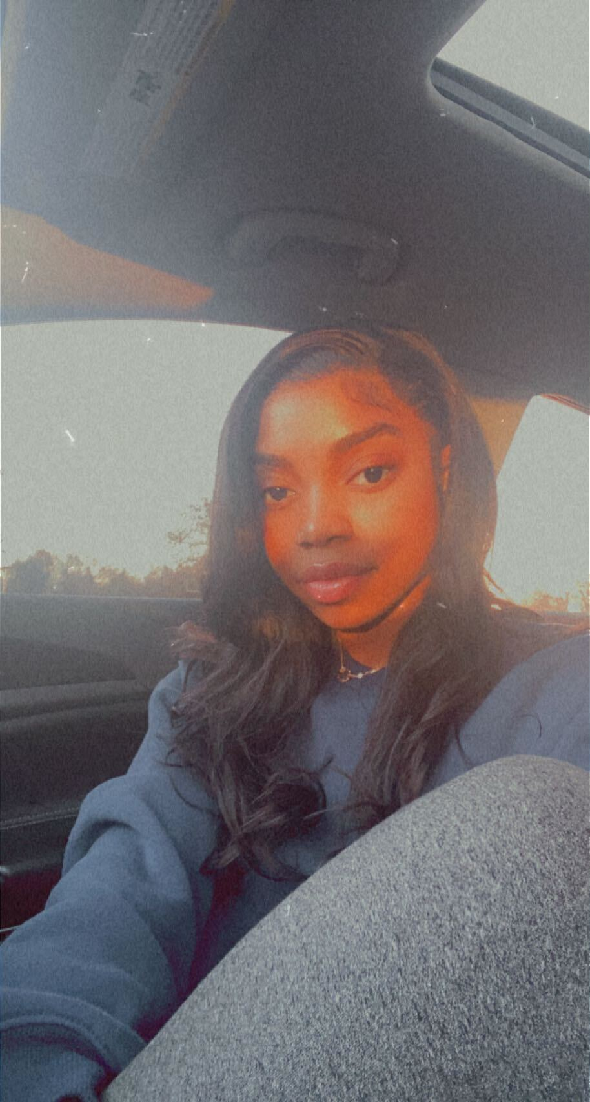- Bryanna

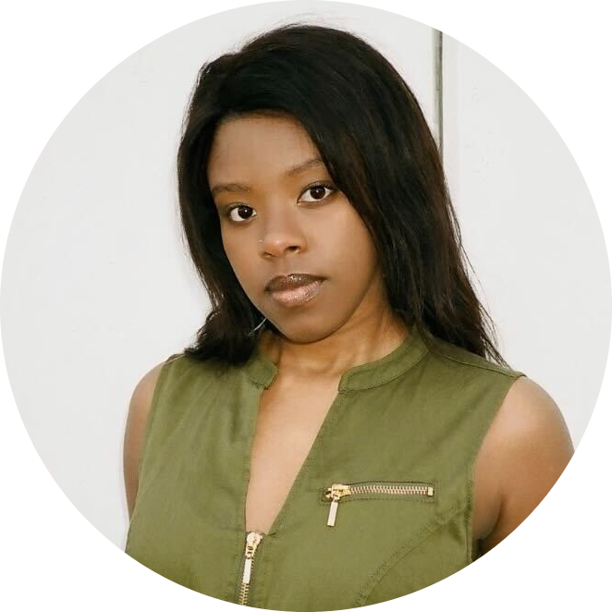Michelle

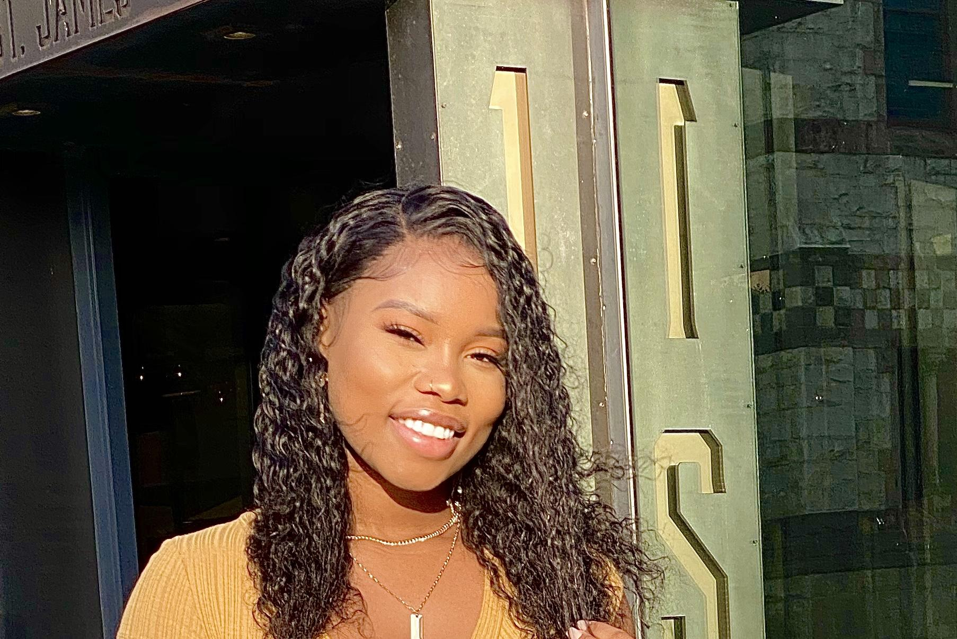

Tina